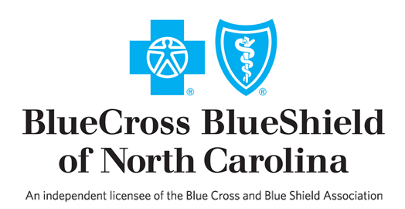

**Teaching Fellows Institute Farm to Table Brunch**

**Sponsored by:**

**BlueCross BlueShield of North Carolina**

**And**

**7th Street Public Market**

***Event Speaker Information***

2:15 p.m. Barbara Caldwell, TFI, Executive Director - Welcome

2:20 p.m. Ellison Clary, BCBS, Director, Charlotte Community Relations - Welcome

2:25 p.m. Steve Case, Slow Food Charlotte, Director -Summary of Slow Food movement

2:35 p.m. Adam Spears, Chef/Owner Local Loaf Restaurant – Sourcing local food

2:40 p.m. Mike Restiano, Executive Director of 7th Street Public Market – field trips

2:45 p.m. Sue Varga, TFI alumna, lesson resources